**The Anatomy and Physiology of Animals/Endocrine System Worksheet/Worksheet Answers**

1. Fill in the gaps in the sentences below using the words in the list.

**target; blood system; ducts; hormones**

a. Endocrine glands release their secretions directly into the blood. In other words they have no *ducts*.

b. Endocrine glands secrete chemicals called *hormones*.

c. Hormones are transported from the endocrine glands to all parts of the body by the *blood system.*

d. Although hormones are carried throughout the body they only affect specific *target* organs and tissues

2. The position of endocrine organs have been indicated in red on the diagram of a composite male and female dog shown below. Add the labels in the list to the diagram.

**Ovary; Pancreas; Thyroid gland; Pituitary gland; Testis; Adrenal gland; Pineal gland; Parathyroid gland**

[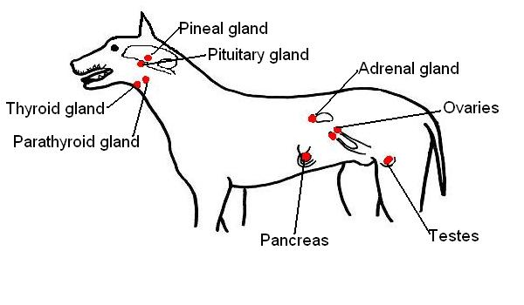](https://wikieducator.org/File:Endocrine_organs_of_dog_labelled.JPG)

3. On the diagram of the brain below, indicate the position of the **Hypothalamus** and **Pituitary gland.**

[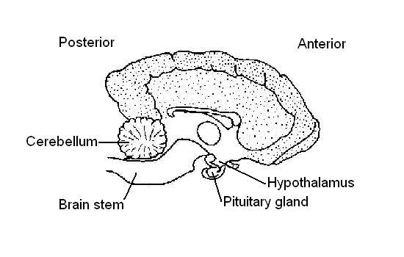](https://wikieducator.org/File:Dog%27s_brain_showing_position_pituitary_and_hypothalamus.JPG)

4. In the table below, list 3 hormones produced by the **pituitary gland** and state the function of each.

|  |  |
| --- | --- |
| **Hormone** | **Function** |
| 1.*Growth hormone.* | *Stimulates growth of the body by increase in length of the long bones* |
| 2.*Oxytocin* | *Stimulates milk "let down"* |
| *3.Follicle stimulating hormone (FSH)* | *Stimulates the development of the ovarian follicle.* |
| *Plus: Luteinising hormone(LH)* | *Stimulates development of the corpus luteum of the ovary* |
| *Plus: Antidiuretic hormone (ADH)* | *Stimulates the production of concentrated urine* |
| *Plus some others* |  |

5. Fill in the following table with the endocrine organ the hormones are produced by.

|  |  |
| --- | --- |
| **Hormone** | **Produced by:** |
| Insulin | *Pancreas* |
| Progesterone | *Corpus luteum* |
| Oestrogen | *Ovarian follicle* |
| Growth hormone | *(Anterior) pituitary gland* |
| Adrenaline | *Adrenal medulla* |
| Antidiuretic hormone | *(Posterior) pituitary gland* |
| Testosterone | *Testis* |
| Aldosterone | *Adrenal cortex* |
| Melatonin | *Pineal gland* |
| Oxytocin | *(Posterior) pituitary gland* |
| Thyroxine | *Thyroid gland* |

6. Match the hormones in the list below with their functions.

**Oxytocin; Insulin; Oestrogen; Growth hormone; Antidiuretic hormone; Testosterone; Adrenaline; Cortisone; Melatonin; Progesterone; Thyroxine; Luteinising hormone; Follicle stimulating hormone**

|  |  |
| --- | --- |
| **Hormone** | **Function** |
| *Follicle stimulating hormone (FSH)* | 1. Stimulates development of the ovarian follicle. |
| *Oxytocin* | 2. Stimulates milk “let down”. |
| *Insulin* | 3. Controls blood glucose levels. |
| *Thyroxine* | 4. Influences the rate of growth and development of young animals. |
| *Growth hormone* | 5. Stimulates the growth of long bones. |
| *Antidiuretic hormone (ADH)* | 6. Stimulates absorption of water from the kidney tubule. |
| *Melatonin* | 7. Influences the development of sexual maturity. |
| *Luteinising hormone (LH)* | 8. Stimulates the development of the corpus luteum. |
| *Oestrogen* | 9. Stimulates the development of female sexual characteristics. |
| *Testosterone* | 10. Stimulates the development of the male sexual characteristics. |
| *Cortisone* | 11. Affect glucose, protein and fat metabolism. |
| *Progesterone* | 12. Prepares the lining of the uterus for pregnancy. |
| *Adrenaline* | 13. Prepares the body for emergency situations. |

7. Circle the odd one out.

1. *melatonin*; oxytocin; growth hormone; antidiuretic hormone; follicle stimulating hormone. *Melatonin is the only hormone in the list not produced by the pituitary gland.*

2. progesterone; oestrogen; luteinising hormone; *cortisone*; follicle stimulating. *Cortisone is the only hormone in the list not involved in any major way with reproduction*.

3. adrenaline; cortisone; aldosterone, oestrogen, *insulin*. *Insulin is the only hormone in the list not produced by the adrenal gland.*